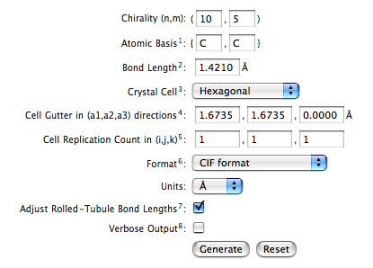

cd /home/Ebbe/desktop/tubegen/trunk
make clean
make all
cd Desktop/tubegen/trunk/build/
ls
./tubegen
help
set format cif
set chirality 9,9
generate
save filename
exit

Had to fix case on ANSR.cpp and ANSR.h

